**Name**: Momenah Saif **Roll No.:**21I-1909

# **Assignment -1**

**Q1: Install and demonstrate the functionality of these basic tools to illustrate the**

**following security capabilities of a system/communication?**

# Bit locker:

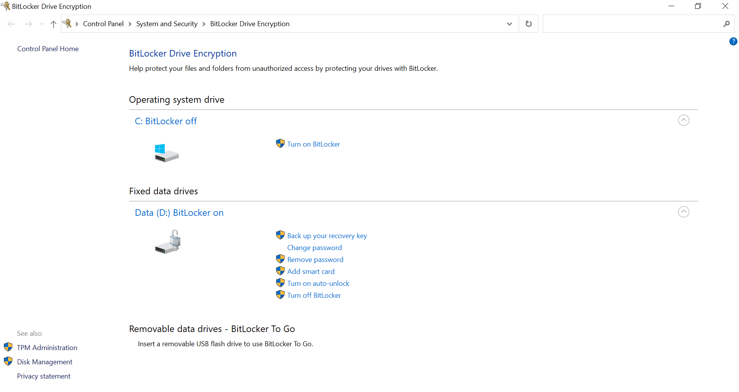

BitLocker is used to encrypt data. It is a feature of Windows

# VeraCrypt:

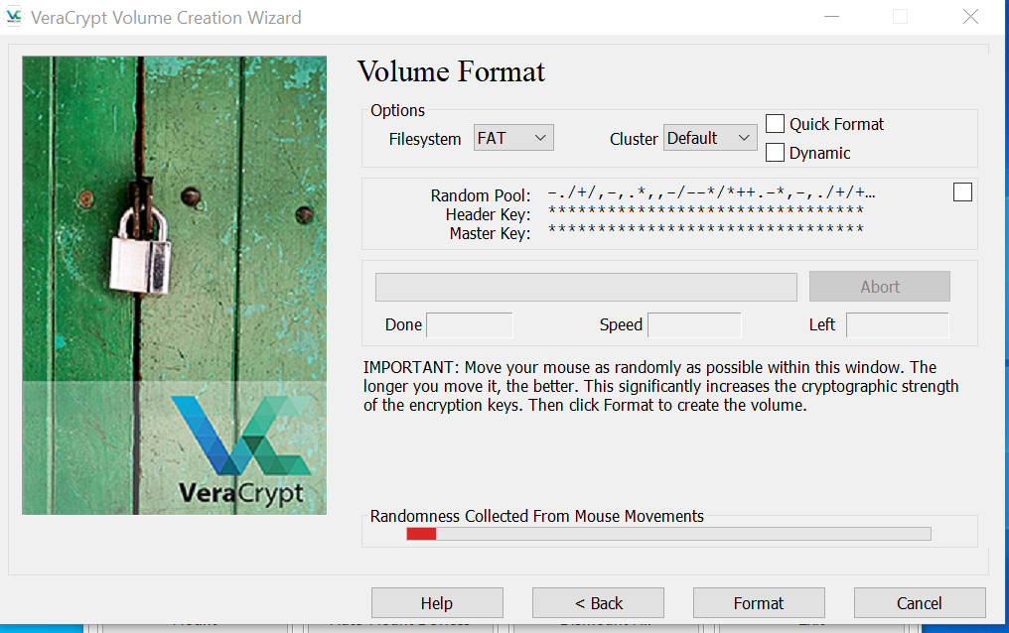

Vera Crypt is used to encrypt disks in computer.

# IgorHasher:

Igor Hasher is used to calculate hashes like MD5, SHA1 and many more.

# Hash Check:

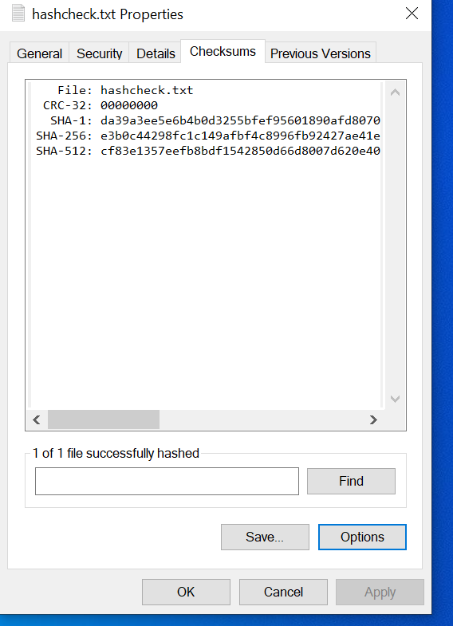

Hash Check Shell calculate hashes of file.

# SolarWinds Security Event Manager:

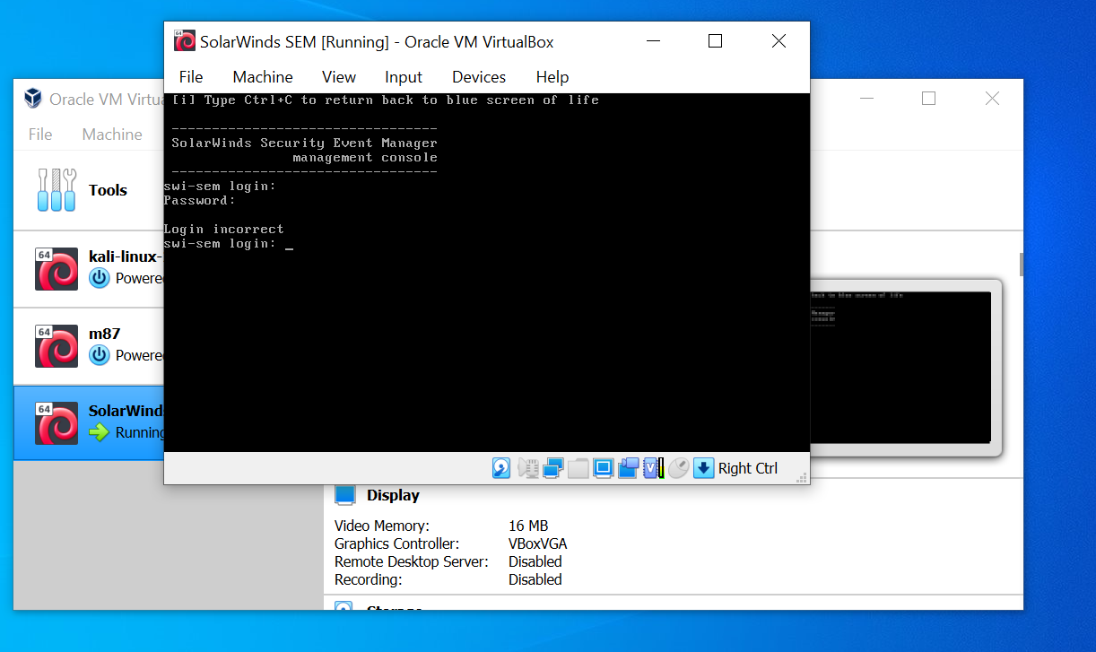

Solar Wind allows people to work in a secure environment.

# Wireshark:

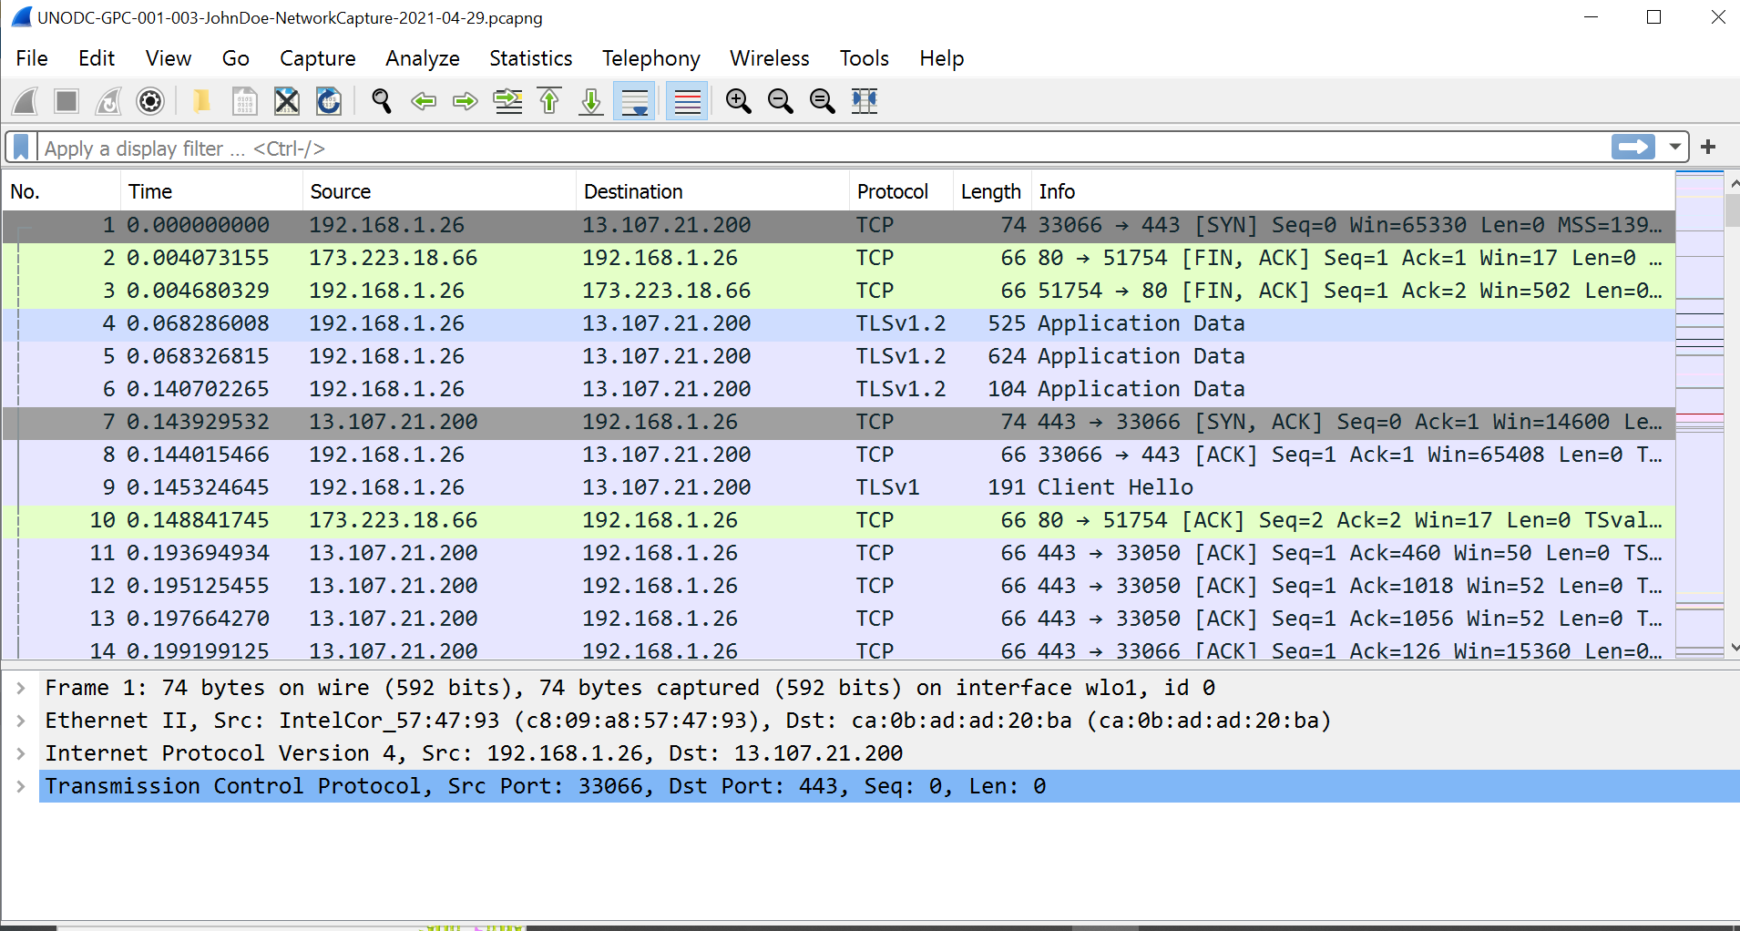

Wireshark is used to monitor data flowing in a network.

# Manage Engine:

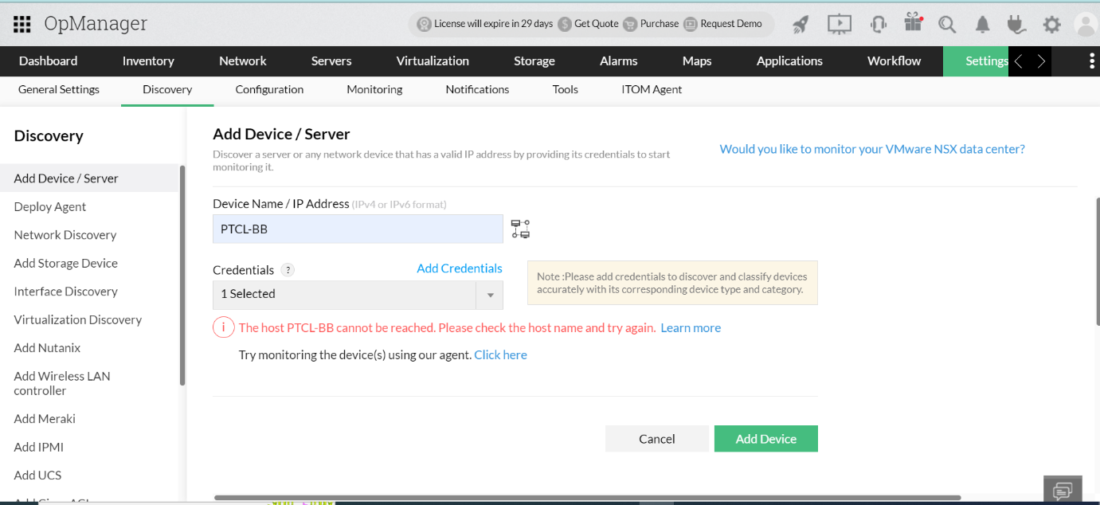

Manage Engine offers enterprise IT management software service management, operations management, Active Directory and security needs.

# N-able N-sight:



N-able N-sight is the world's largest IT Service Management (ITSM) platform, it empowers IT professionals to manage, monitor and secure their networks .

# Tor Browser:

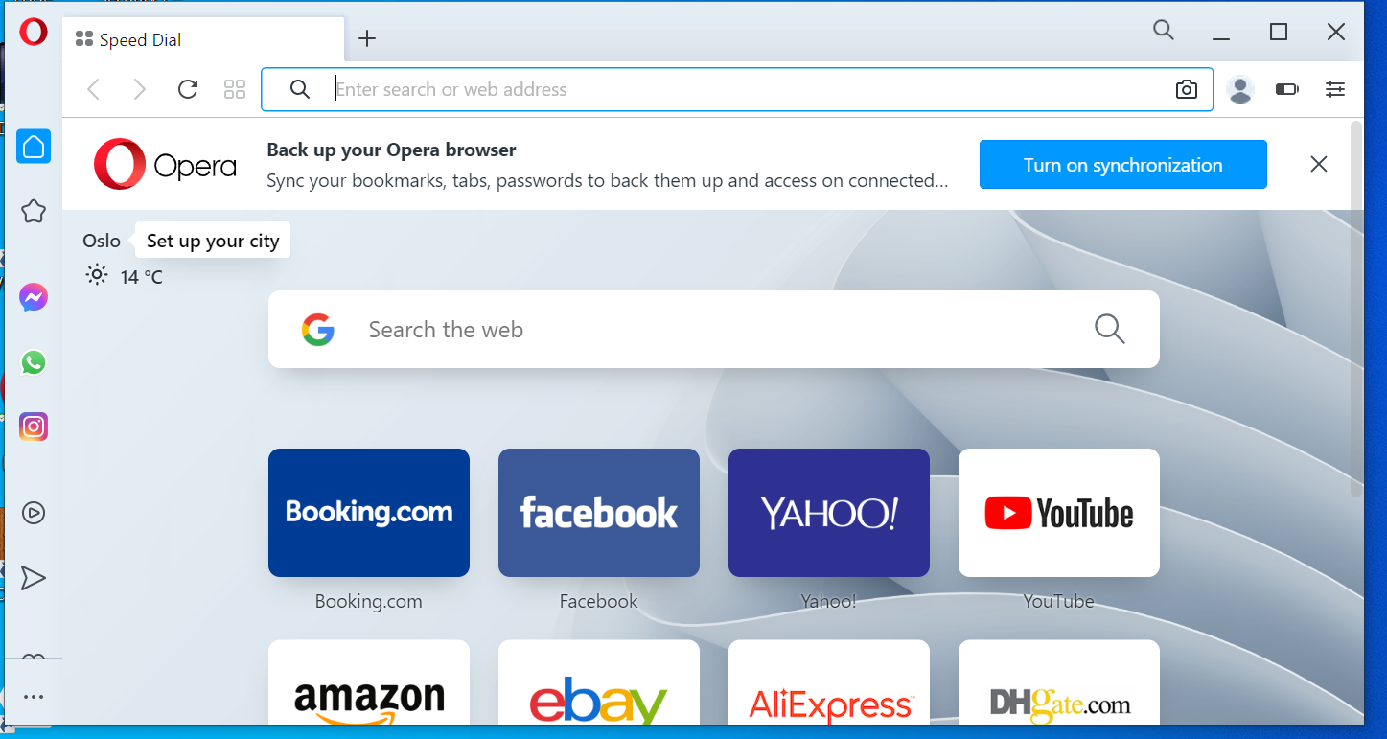

Tor Browser provides privacy to its user while online working.

# Privacy Bee:

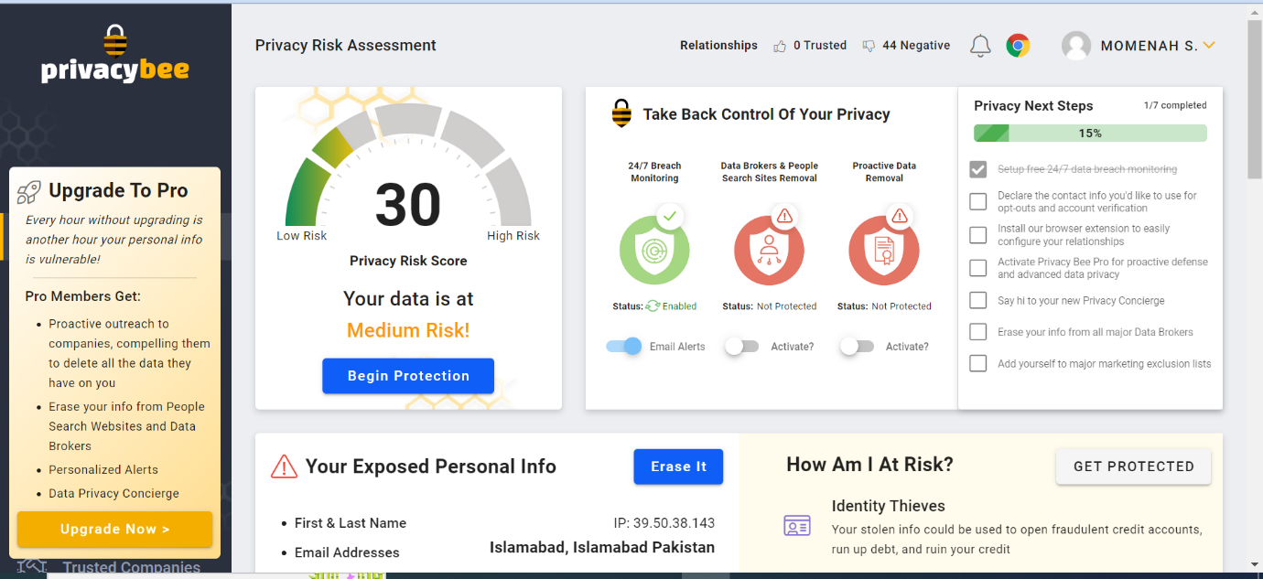

Privacy Bee ensures that its users identity is not stolen.

# Kisi:

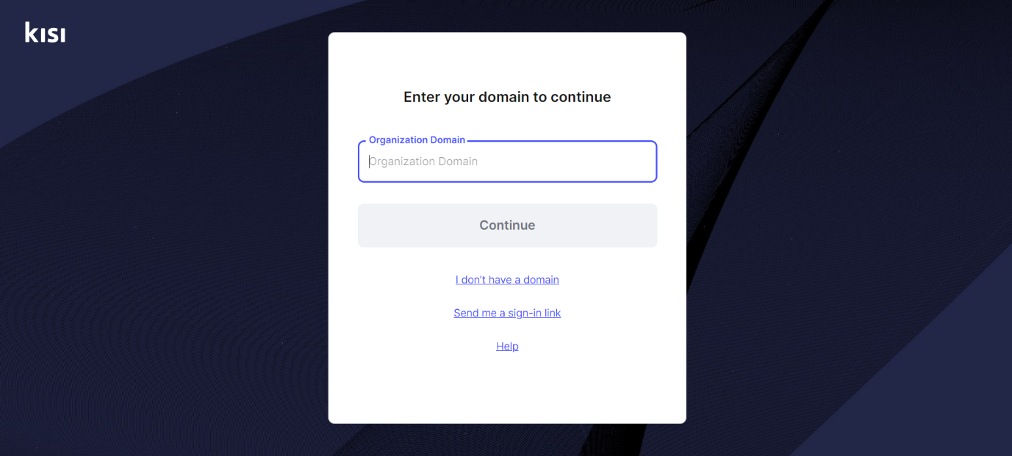

Kisi is a remotely managed cloud system that integrates with a variety of hardware devices and software tools

# Hide ‘N’Send:

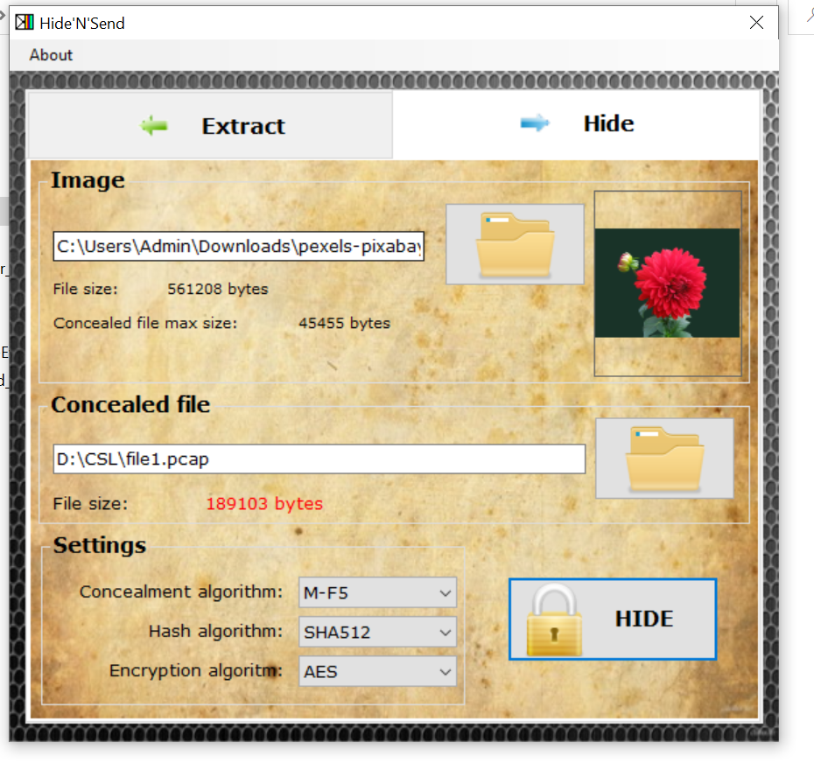

Hide ‘N’ Send is used for steganography. It is used to hide data in an image.

# SSuite Picsel:

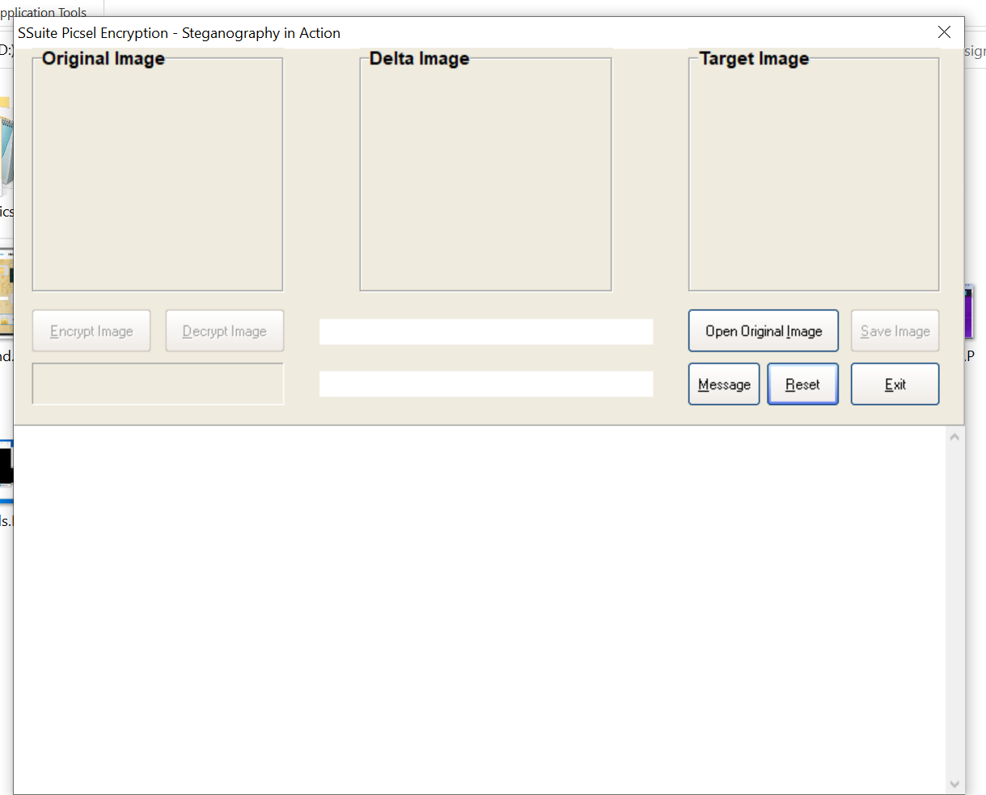

Ssuite picsel is a free security software application used for steganography, it provides an unbreakable encryption method using only images as your key; no password necessary.

# Last Pass:

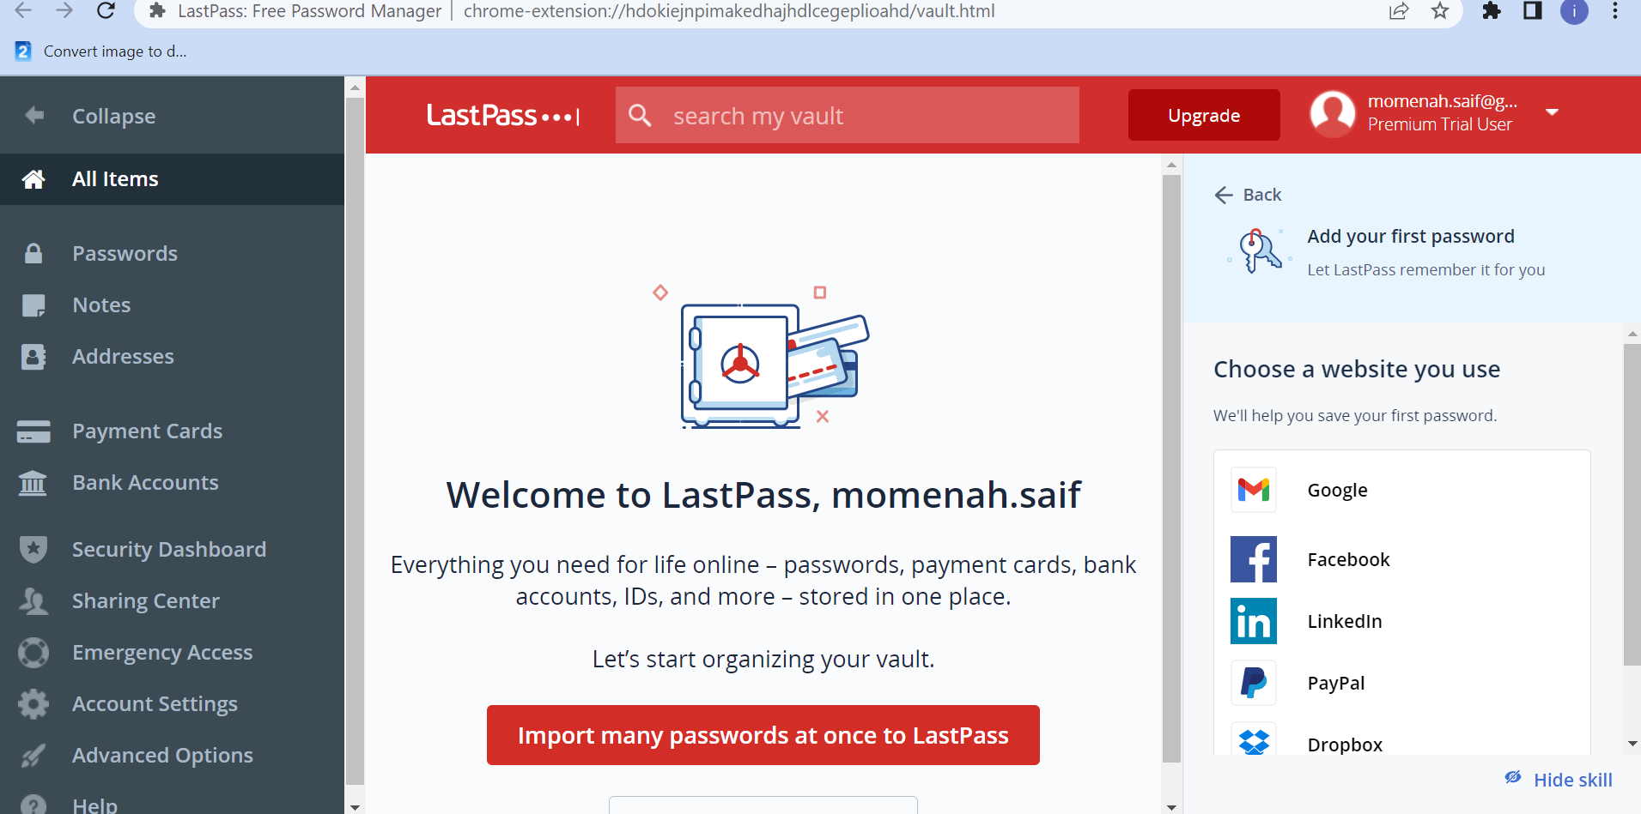

LastPass is a free password manager that stores encrypted passwords online.

# Duo Security:

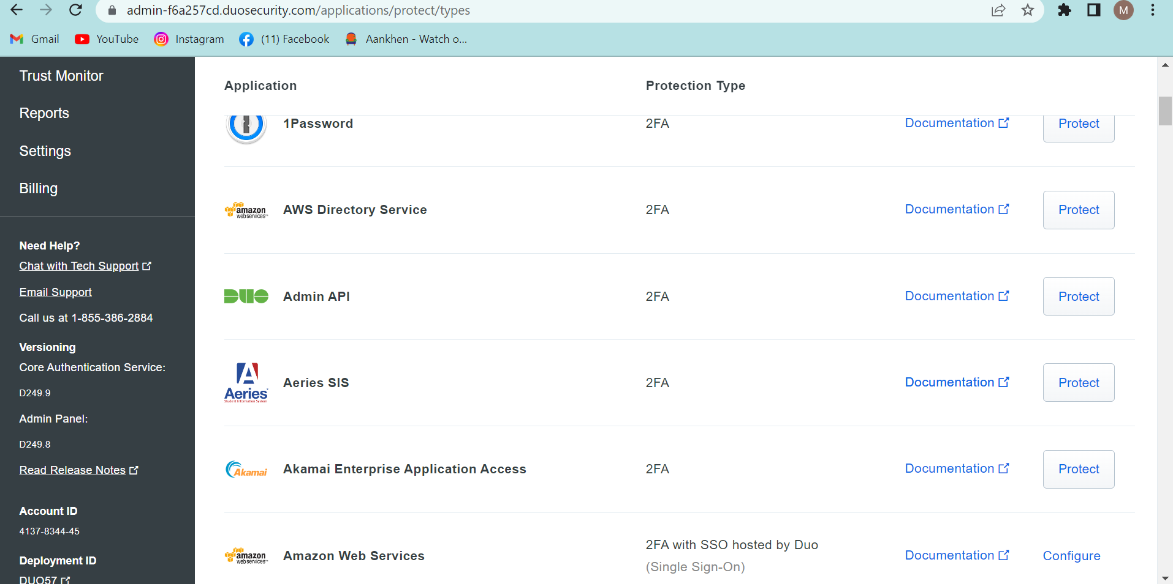

Duo Security prevents data breaches with strong authentication.

**Q2: Implement following simple encryption/ decryption algorithms in:**

1. Caesar cipher (with fix Key=3)

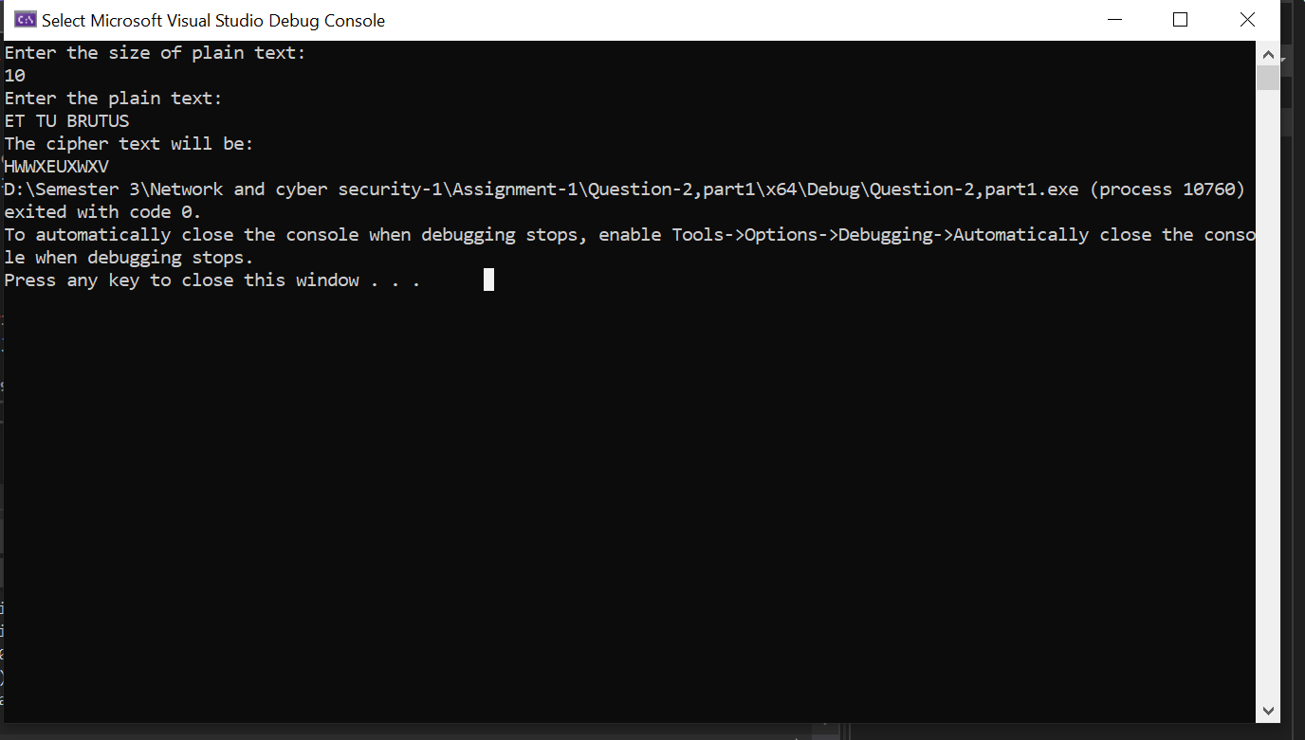

2. Write a simple cracker to find all 26 combinations of text encrypted with

Caeser at fix key=3

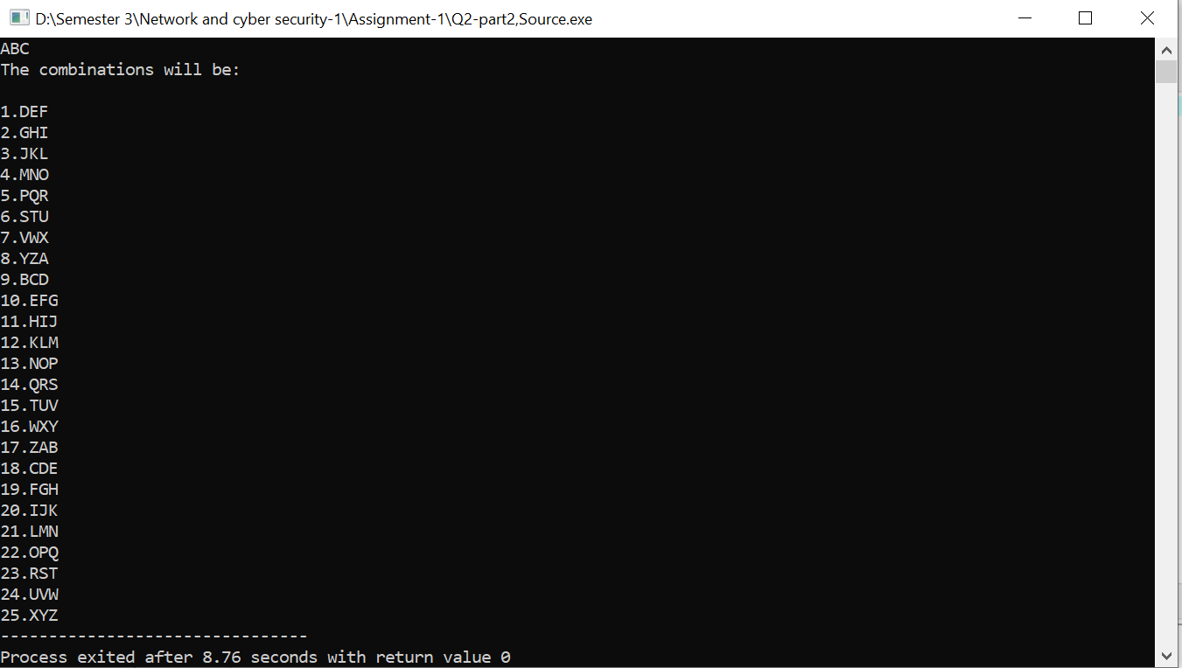

1. Simple Substitution cipher (with Key range from 1-26 randomly)

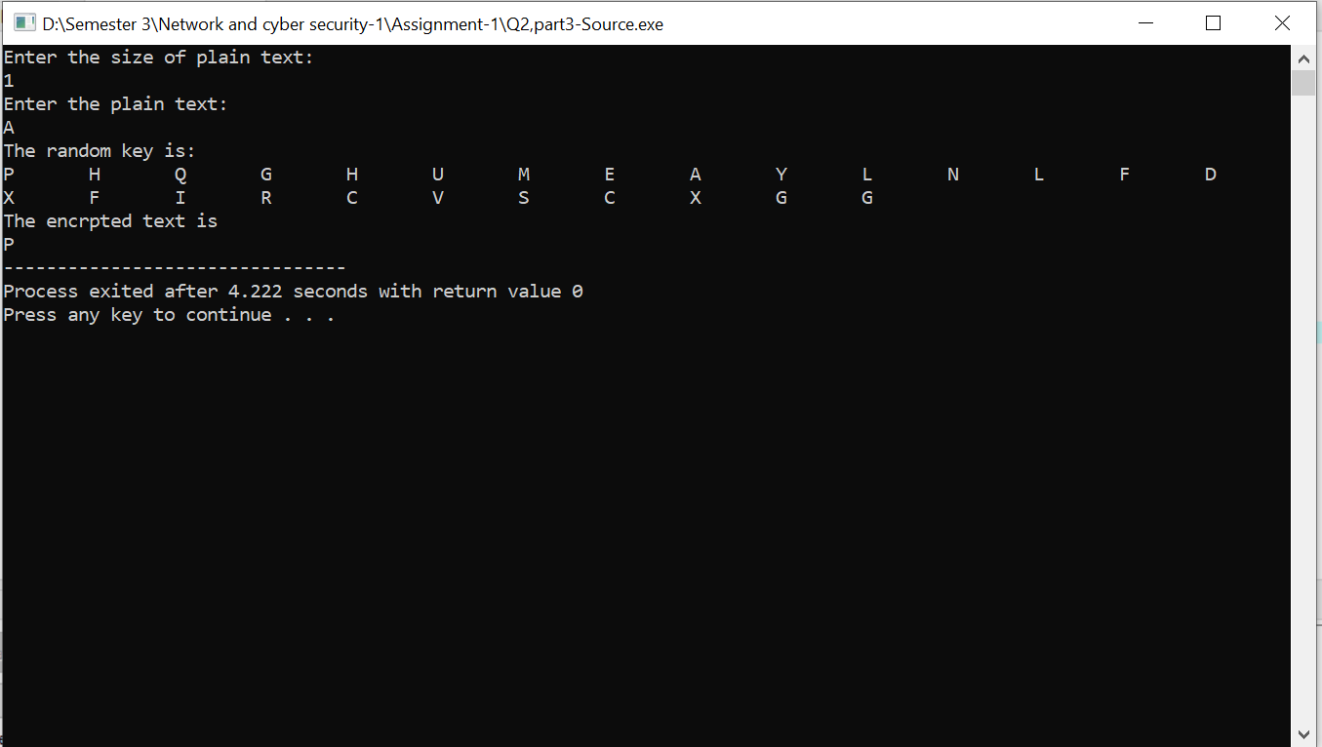

1. Playfair encrypter and decypter

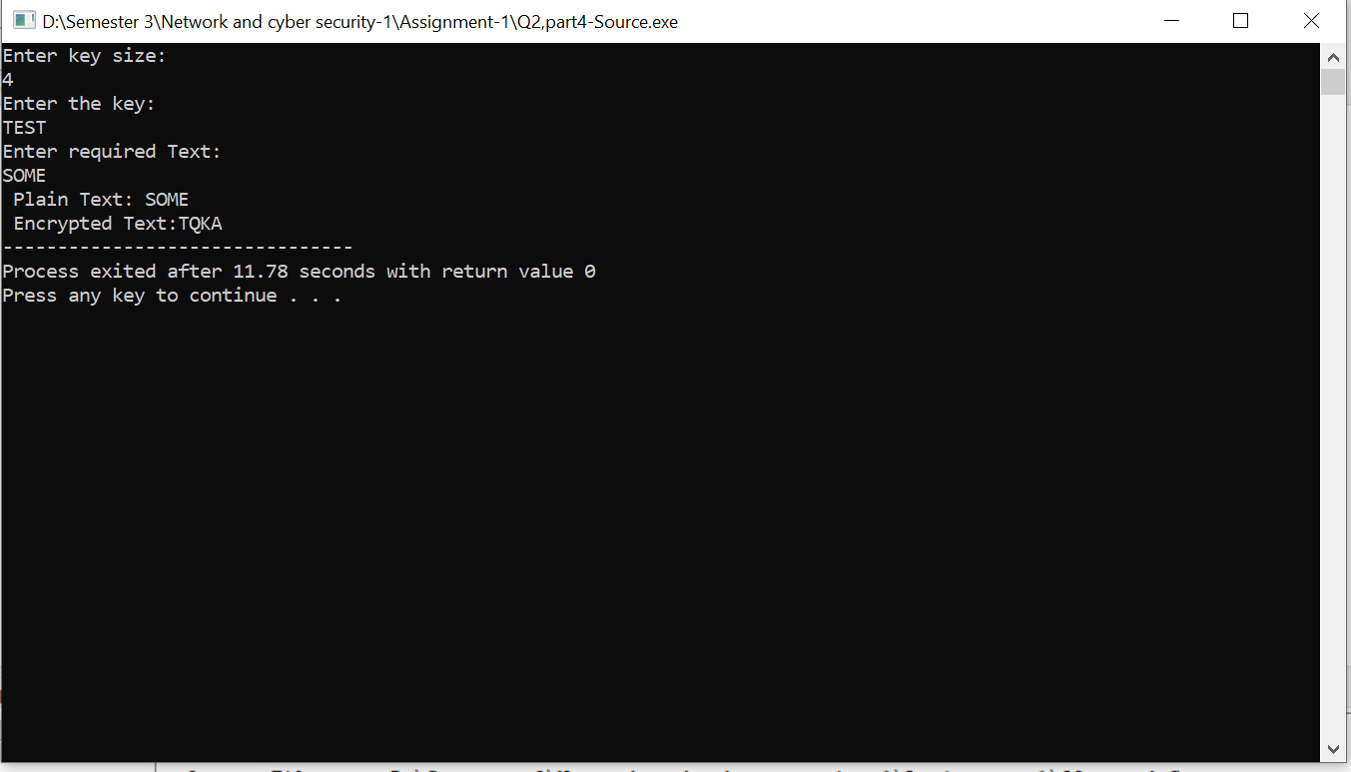

1. Vigenere cipher encrypter and decypter

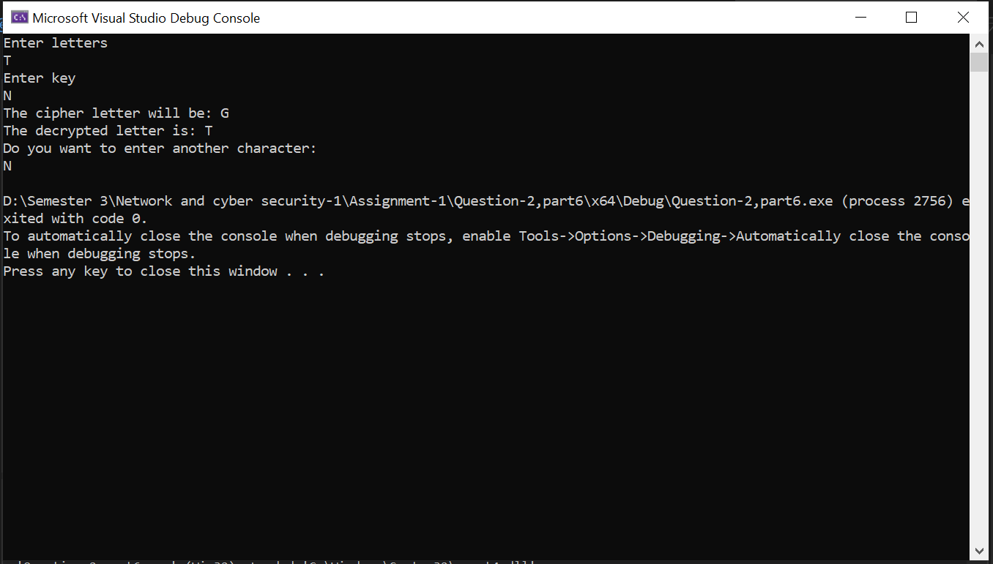

7.a single columnar transposition cipher

